Searching the Official Gazette

NOTE: I cannot guarantee these searches will catch all pending trademarks. You may need to use your own judgement when searching for other options.

Trademarks which are presented for opposition are listed in this gazette. You have 30 days to oppose the trademark once it appears in the Gazette.

Those are trademarks that have been ALLOWED by the USPTO, but they are not yet REGISTERED. All marks must first get published for opposition for 30 days (and an opposer can file an extension if needed), before they can be registered.

- Go to the USPTO’s Trademark Search Database by clicking this link: http://tmsearch.uspto.gov
- Scroll down to Additional Search Options and choose “Search OG Publication Date or Registration Date (Search OG).”
- Choose “Goods and Services” from the second Field drop-down.

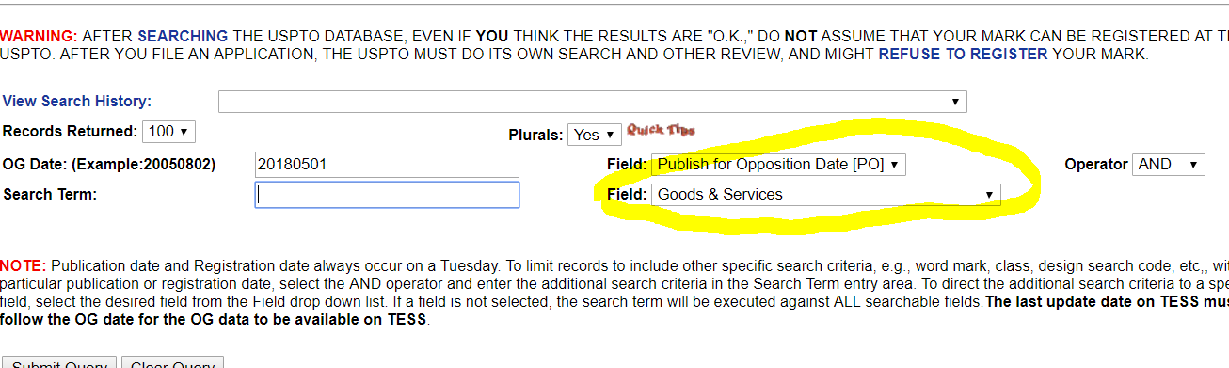

- Leave the date as is to search the most current Gazette.
- In the search term field, type your search term. I had the most success with these search terms:
  - Fiction
  - Romance
  - Ebooks
- Click the Submit Query button.
- A list is displayed of all items matching your search terms.
  - If the list is longer than one page, you can press “Next List” to see the next set of 100 items.

- If you’d like to see more information on a particular item, click on TDSR for that item.

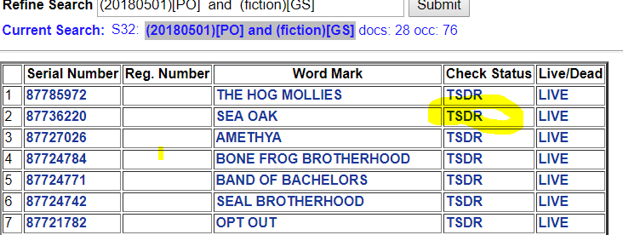

- Click your browser’s Back button to go back to your original search and do another search.

Searching the Trademark Database

If you’d like to search the database for items that haven’t been officially registered yet or necessarily published in the Gazette, you can do a database search.

- Go to the USPTO’s Trademark Search Database by clicking this link: http://tmsearch.uspto.gov
- Click the link for “Word and/or Design Mark Search (Free Form).”
- Enter your Boolean search term and click Submit Query. You can use Help for info on searches or scroll down to my section on “Sample Searches for Possible Romance Trademarks” and cut and paste in any of these searches.
  - The example below searches for all live trademarks (Live) with no registration number (RN) in the category of 009, which is where eBooks are classified, and in the field of romance.
  - See below under the “Sample Searches for Possible Romance Trademarks” heading for more sample searches that I found effective.

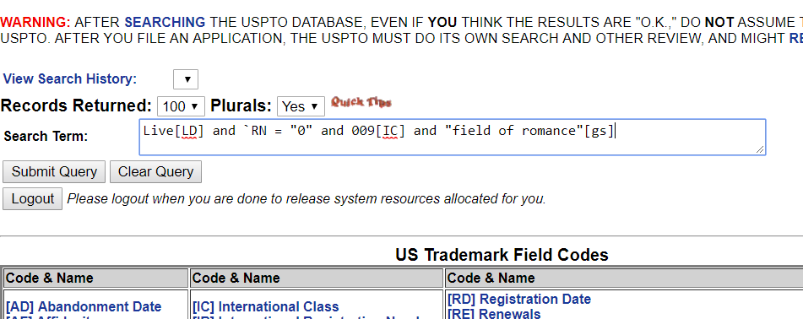

- A list is displayed of all items matching your search terms.
  - If the list is longer than one page, you can press “Next List” to see the next set of 100 items.

- If you’d like to see more information on a particular item, click on TDSR for that item.

- Click your browser’s Back button to go back to your original search and do another search.

Sample Searches for Possible Romance Trademarks

Please note that in the below searches for `RN = "0" that is an accent mark not an apostrophe.

I had success with these searches:

EBOOKS:

All live trademarks with no registration number (not yet registered) in the 009 Classification and with field of romance listed as the Goods and Services:

Live[LD] and `RN = "0" and 009[IC] and "field of romance"[GS]

All live trademarks with no registration number (not yet registered) in the 009 Classification and with fiction listed as the Goods and Services:

Live[LD] and `RN = "0" and 009[IC] and "fiction"[GS]

All live trademarks with no registration number (not yet registered) in the 009 Classification and with romance listed as the Goods and Services:

Live[LD] and `RN = "0" and 009[IC] and "romance"[GS]

PAPERBACKS:

All live trademarks with no registration number (not yet registered) in the 016 Classification and with field of romance listed as the Goods and Services:

Live[LD] and `RN = "0" and 016[IC] and "field of romance"[GS]

All live trademarks with no registration number (not yet registered) in the 016 Classification and with fiction listed as the Goods and Services:

Live[LD] and `RN = "0" and 016[IC] and "fiction"[GS]

All live trademarks with no registration number (not yet registered) in the 016 Classification and with romance listed as the Goods and Services:

Live[LD] and `RN = "0" and 016[IC] and "romance"[GS]

